Available online at www.sciencedirect.com **ScienceDirect**



Procedia Computer Science 89 ( 2016 ) 320 – 323

Twelfth International Multi-Conference on Information Processing-2016 (IMCIP-2016)

# Weather Forecasting using Arduino Based Cube-Sat

M. Rahaman Laskar*a,*∗, R. Bhattacharjee*a*, M. Sau Giri*a* and P. Bhattacharya*b*

*aCalcutta Institute of Engineering and Management,*

*Tollygunge, Kolkata, West Bengal 700 040, India bNational Institute of Technology, Agartala, Tripura 799 046, India*



## Abstract

Weather is the state of atmosphere at a particular time and place with regard to temperature, moisture, air pressure, precipitation etc. Bio organisms need to adapt with the changing atmospheric conditions. It is therefore important to know the atmospheric condition for different applications. The interest is to design an autonomous small cube satellite which can provide the information of weather from anywhere without using Network. Here a hardware model has been designed and implemented. It is possible to provide instant weather report which can be used to compare the data of a place with some different altitude as well as for different time instant. In meteorology, the main objective is to know accurate weather conditions with less human efforts, reliable and efficient data. As the weather varies from place to place and with the altitude, it is difficult to get accurate weather for a particular location. With the advancement of technology, specially embedded system & data acquisition systems, the problem of large set up area and cost has been reduced significantly. Cube–Sat can be set up at home as well as in atmosphere or in space which can provide accurate weather report.

© 2016 The Authors. Published by Elsevier B.V.

© 2016 The Authors. Published by Elsevier B.V. This is an open access article under the CC BY-NC-ND license

(Peer-review under responsibility of organizing committee of the Twelfth International Multi-Conference on Informationhttp://creativecommons.org/licenses/by-nc-nd/4.0/). Peer-review under responsibility of organizing committee of the Organizing Committee of IMCIP-2016Processing-2016 (IMCIP-2016).

*Keywords:* Arduino Uno; Data Analysis; Data Transmission; Sensor; Wireless Communication.



## 1. Introduction

People since nineteenth century became able to predict the environmental conditions. The only difference between the primitive and the modern system is that the advancement of technology. The measuring instrument has become miniaturized, efficient, reliable and more accurate to provide instant weather report without manpower. Weather being a natural phenomenon always change with the change of different atmospheric parameters. Still, the average or mean condition can be predicted which ultimately gives the climate of a geographical area for a long time consideration. The most important parameters that affect the atmospheric conditions are air pressure, temperature and humidity. All these parameters are subject to change with change of altitude, day length (intensity of sunlight changes), environmental components (tropical zone, or temperate zone etc.), sun angle at particular spot etc.

In modern system of weather forecasting, the environmentaldata are sent to a computerbased system througha Data Acquisition Systems (DAS). Multiple parameters are multiplexed and finally proceeding through a single channel to the computer to show the data. For Broadcasting, the data taken by the sensors are recorded in satellite based system which communicates through wireless data transmission system and displayed either in a television or in the internet broadcasting media.



∗Corresponding author. Tel.: +91-9674599866. *E-mail address:* m.rahaman93@gmail.com

1877-0509 © 2016 The Authors. Published by Elsevier B.V. This is an open access article under the CC BY-NC-ND license (http://creativecommons.org/licenses/by-nc-nd/4.0/).

Peer-review under responsibility of organizing committee of the Organizing Committee of IMCIP-2016 doi: 10.1016/j.procs.2016.06.078

*M. Rahaman Laskar et al. / Procedia Computer Science 89 ( 2016 ) 320 – 323* 321

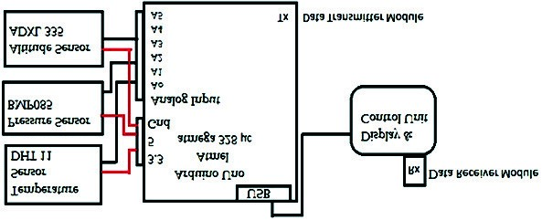

Fig. 1. Block Diagram of the Complete System.

### 1.1 Literature review

The topic of weather monitoring is not new. However, location based accurate monitoring system without using network is rare1,2. Most of the previous works have shown a complicated hardware system and different devices were made for the analysis of different weather parameters3,4. Satellite based systems in primitive days were not cost efficient. A few works have been done using embedded applications5.

The proposedmodel of the cube satellite is cost efficient, reliable and simplest design ever6,7. The graphical analysis of data taken for 4 months consecutively in Kolkata with the help of gas balloon has shown that this system is working properly. The statistical data obtained from the device for different altitudes and in different times is a unique feature of the device which provides about 90% and above accurate and similar data compared with network based existing system.

### 1.2 System overview

This proposed system is simple to design. Here, three different sensors are used which are temperature & humidity sensor (DHT11), pressure sensor (BMP085) and Accelerometer (ADXL-335). The data processing unit is an Arduino Uno which is a low cost embedded system platform. The data can be recorded and analyzed in a personal computer or in a simple android based mobile phone with Arduino application installed. To transmit the data, the cube-sat to the monitoring device, a transmitter and receiver module is used. An RF module of 433MHz is used for this data transmission. A gas balloon has been used to hold & carry the Cube satellite.

## 2. Working Principle

The data controlling unit is an embedded system platform. Here an Arduino Uno is used. It is powered by 9V battery & programmed for the specific applications using Arduino open source software (Arduino 1.6.1). The temperature and humidity sensor DHT 11 is connected to Arduino Uno. Pin no. 1, 2 and 4 of DHT11 is connected with Pin no. GND (ground), A0 and 5V (supply) respectively. DHT11 collects environmental data and send it to the Arduino Uno for digitally processing analysis of data. The pressure sensor BMP085 takes the pressure data from the environment. The connection of BMP085 to the Arduino Uno is done as follows: Vcc to 3.3V, SDA to A4, SDL to A5 and GND to GND. Accelerometer ADXL 335 is used. The connection of the accelerometer to the Arduino is done as follows; X to A1, Y to A2, Z to A3, pin 5 to Pin 5 (supply), GND to GND. All these modules are set into a cube box of small dimension. A transmitter & receiver module is also connected with the system. An RF transmitter-receiver module of 433MHz is used for wireless data transmission. The cube-sat can be placed anywhere. The block diagram of the complete system is shown in Fig. 1. Working prototype and model of the cube satellite is shown in Fig. 2.

## 3. Results and Discussion

Pressure, humidity temperature against variation of altitude in Kolkata has been measured in the month of July, 2015. Table 1 shows the comparison of pressure, humidity and temperature with respect to the variation of altitude.

322 *M. Rahaman Laskar et al. / Procedia Computer Science 89 ( 2016 ) 320 – 323*

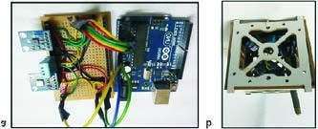

Fig. 2. (a) Working Prototype; (b) Cube Satellite Model.

Table 1. Comparison of Pressure, Humidity and Temperature Data with respect to the variation of

Altitude.

|  |  |  |  |  |  |
| --- | --- | --- | --- | --- | --- |
| Altitude  X axis Y axis | | Z Axis | Pressure (Pa) | Current Humidity | Temperature (Celsius) |
| 992 1008 1007 | 752 | 86.50% | 34.00 |  |  |
| 997 1022 1022 | 748 | 85.00% | 32.00 |  |  |
| 998 1024 1024 | 742 | 84.00% | 31.50 |  |  |
| 1008 1046 1046 | 740 | 82.00% | 30.00 |  |  |
| 1020 1068 1068 | 715 | 78.00% | 27.50 |  |  |

Table 2. Comparison of Temperature Data with respect to Time Variation.

|  |  |  |
| --- | --- | --- |
| Month | Day | Temperature (average in Celsius) |
| July | 1st | 32.00 |
| July | 15th | 34.50 |
| August | 1st | 28.00 |
| August | 15th | 33.00 |
| September | 1st | 30.50 |
| September | 15th | 32.00 |
| October | 1st | 35.00 |
| October | 15th | 31.00 |

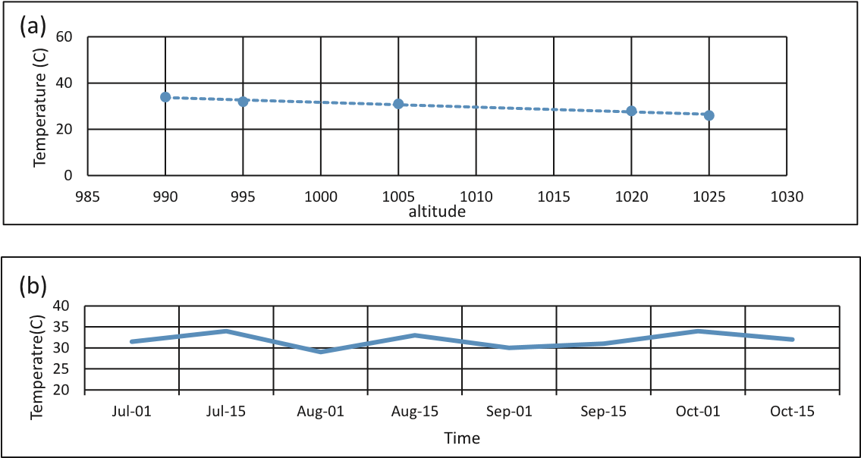

Fig. 3. (a) Graphical Analysis for Temperature versus Altitude Data from Table 1; (b) Graphical Analysis for Temperature versus Time Data from Table 2.

Among all these three parameters, temperature variation has the highest impact on industrial applications such as production, manufacturing etc. Data for the variation of temperature for four months have been recorded from July to October, 2015 in Kolkata. The recorded data is compared with the data from existing internet network based data and weekly weather report of India Meteorological Department.

*M. Rahaman Laskar et al. / Procedia Computer Science 89 ( 2016 ) 320 – 323* 323

## 4. Conclusions

We have designed and implemented a cube-sat based weather monitoring system. The system is simple to construct, portable, cost efficient, less power consuming and reliable. We demonstrate the hardware design and the data acquisition system. The records of different weather parameters for 4 months with the variation altitude and time period have shown.

As the system does not use internet network, data transmission has low cost which in terms provide large applications. It will have a positive impact on agriculture and production. There are some limitations such as the device may not communicate to a long distance without powerful transceivers section, the record of data in higher altitude with the help of gas balloon may be a problem. The components may be damaged by rain or long time use.

## References

1. F. Satoh and M. Itakura, Cloud-based Infrastructure for Managing and Analysing Environmental Resources, *SRII Global Conference*, pp. 325–334, 2011.
2. Q. Wei, N. Jin, X. Lou, R. Ma and J. Xu, Software Design for Water Environment Remote Monitoring System Based on Mobile Devices, *Applied Mechanics and Materials*, pp. 2027–2032, (2011).
3. Y. Zhengtong and Z. Wenfeng, The Research of Environmental Pollution Examination System Based on the Cloud Computing, *International Conference on Communication Software and Networks*, pp. 514–516, (2011).
4. P. Kinney, ZigBee Technology: Wireless Control that Simply Works, Communications Design Conference Secretary of ZigBee BoDChair of ZigBee Building Automation Profile WG, 2 October (2003).
5. Karthik Krishnamurthy, Suraj Thapa, Lokesh Kothari and Arun Prakash, Arduino Based Weather Monitoring System, *International Journal of Engineering Research and General Science*, vol. 3, issue 2, ISSN 2091-2730, March–April (2015).
6. Columbia-Weather, Pegasus EX Portable Weather Station – Columbia Weather Systems, Inc. http://www.columbiaweather.com/Pegasus EX-Brochure.pdf, Accessed, 3 June (2010).
7. M. Ibrahim and M. Youssef, Cell Sense: An Accurate Energy-Efficient GSM Positioning System, *IEEE Transactions on Vehicular Technology*, vol. 61, pp. 286–296, (2012).
8. Weather and Environmental Monitoring Sensors, Springer US, pp. 496–523, (1994).
9. N. Adam, V. Atluri, S. Yu and Y. Yesha, Efficient Storage and Management of Environmental Information, *10th NASA Goddard Conference on Mass Storage Systems and Technologies 19th IEEE Symposium on Mass Storage Systems*, April 15–18, College Park, MA (2002).
10. A. M. Langer EdD, Analysis and Design of Information System, 3rd Edition, Springer, (2008).
11. C. E. A. Mulligan and M. Olsson, Architectural Implications of Smart City Business Models: An Evolutionary Perspective, *IEEE Commun. Mag.*, IEEE, vol. 51, no. 6, pp. 80–85, (2013).
12. Z. Machacek and V. Srovnal, Automated System for Data Measuring and Analyses from Embedded Systems, In *7th WSEAS International Conference on Automatic Control, Modeling and Simulation*, Prague, Czech Republic, March 13–15, pp. 43–48 (2005).